IZAAK WALTON LEAGUE, AMES CHAPTER
BOARD OF DIRECTORS MEETING AGENDA
Meeting May 4, 2021; 6:15p.m.

- Called to order by: Jake S
- Roll call:
  - Board: (See Roll Sheet)
  - Excused: (See Roll Sheet)
- Approve Agenda: Motion- Mark R. 2nd Bill S.
- Approve previous month’s meeting minutes: Motion – Mark R; 2nd Bill S
- Approve previous month’s Treasurer’s Report: Motion – Mark R ; 2nd Bill S
- Members/Guests:
  - Eagle Scout Project - GAGA Ball Pit. Wanting to install the pit. Waterproof and virtually no maintenance. $1000 estimate. Troop 230 would continue maintenance. Add pavers around the outside to allow for mowing. How often would it be used? Primarily by Scouts that camp out and other family using the campground. Want more detailed pricing. Price of lumber is incredibly high. Tabled for more information next month.
- Upcoming Events: See calendar
- Communications:
  - Church Group Use of Park – Dan Sprouse (Ikes member) First United Methodist Church in Nevada. Campout for men/boys one night and women/girls another night. One time for each group. Not reoccurring. They will contact with Roger E. for more details.
  - Development to East of Park (See visual below) – Going to develop the land to small businesses. Going to gift us a little less than an acre that is incorrectly surveyed. We discussed water quality concerns. Discussion about getting an easement/road to accessing the east side of our property.
- Member Comments:
- President’s Comments:
- Committee Reports:
  - Archery (Terry Witt): June 7th archery class. Monday nights. 4 weeks. Open to members and nonmembers. New member wants to paint the shelter area/picnic area.
  - Capital improvements: Jerry will have wiring done within the week on the new storage garage.
  - Chapter House (Roger Elliot): Nothing to report
  - Campground (Roger Elliott): Clean Up Day – Saturday June 5th. Going to get some equipment for tree removal.
  - Conservation/Education (Paul Readhead): Packaged 385 shrubs to third graders.
  - Grounds & Equipment (Roger Elliott): Loads of Gravel needed - 5 to 6 loads. $367.87 per truck load. Motion for up to 6 loads – Steve O. 2nd Roger. PASSED. Dust control – what’s the environmental impact? Can we still work on the road? Board seems to think this isn’t something the park needs. We should look into erosion control along the road. Needs more investigation.
  - Indoor Range (Darin Van Ryswyk): See old business below.
  - Membership (Lee Van Brocklin): See numbers in Lee’s email. National membership will want info on our renewals. Do we need to raise dues? We’ll discuss/vote in June.
  - Outdoor Range (Tod Bertram): Nothing to report.
  - Trap & Skeet: (Mark Robson): Open to Public beginning the third Wednesday of May.
  - Park Resident (Tim Hansen): Nothing to report.
- Old Business: RSO trained board members can use range with notice to Darin.
- New Business: Graber for the tractor to help move brush etc. $2300-2400?
- Next meeting: June 1, 2021
- Motion to Adjourn; Lee VB 2nd – Mark R.

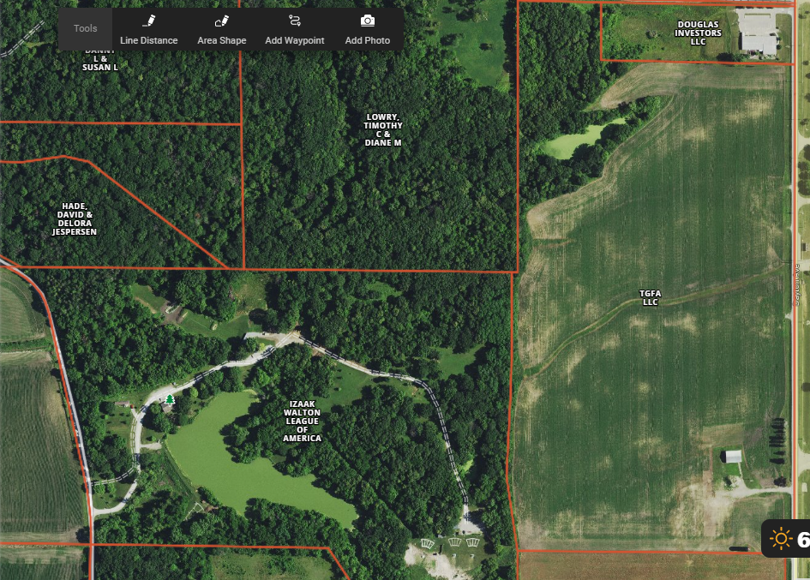

2020-2021 OFFICERS:
President | Jake Strohm
Past President | Aaron Kester
1st VP | Aaron Kester

2nd VP
Secretary | Mike Mauton
Treasurer | Tod Bertram

BOARD OF DIRECTORS:
Name | Term | Initial If Present
Aaron Kester | 2020-2023 | AK
Kevin Martin | 2020-2023
Carrol McCracken | 2020-2023 | CM
Paul Readhead | 2020-2023 | PR
Mark Robson | 2020-2023 | MR
Bob Wnek | 2020-2023 | Excused
Randy Cummings | 2018-2021 | Excused
Howard Van Auken | 2018-2021 | HVA
Mike Mauton | 2018-2021 | MM
Terry Witt | 2018-2021 | TW
Roger Elliott | 2018-2021 | RE
Brian Hill | 2018-2021
Jake Strohm | 2019-2022 | JS
Tod Bertram | 2019-2022 | TB
Steve Olson | 2019-2022 | SO
Tim Hanson | 2019-2022 | TH
Ben Berka | 2019-2022 | Excused
Jerry Anderson | 2019-2022 | JA
Terri Henrich | Honorary
Bill Scott | 2018-2021 | BS

